Setting up the GitHub and VS Code Environment

Follow these steps to complete the setup. If there are any issues, please let me know and/or we will cover this when we meet.

Step 1: Open VS Code.

Step 2: Go to the Extensions tab . From there, search for the following and install them.

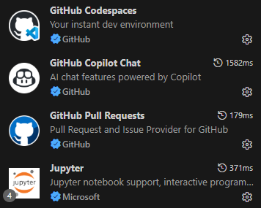

Step 3: Once you are done, you will see a GitHub tab  at the left side. Select this and login to your GitHub account.

You will go through a series of permissions and approvals. This is to ensure you integrate everything. Make sure you approve everything.

Step 4: If you already created your repository, you need to clone it. Go to GitHub.com and login. Go to your repository. Select the  icon and from there, you will see the following:
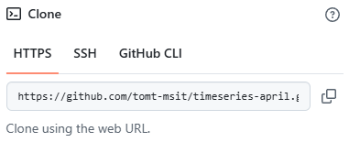

Copy the URL.

Step 5: Go back to VS Code. Press CTRL + Shift + P (Windows) or Cmd + Shift + P (Apple) to open the Command Palette (it is at the top and will look something like this).

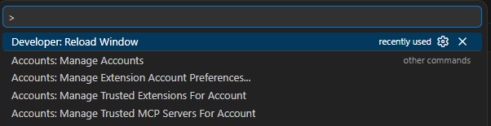

Type at the top Git: Clone and press ENTER. Select Clone from GitHub. Select your repository.

Note: If you do not see it, you will see a step on that space above where you can insert your URL. Paste the URL (HTTPS) from Step 4.

Step 6: You will be directed to save the folder. Select the destination you were given.

Wait while everything loads.

If you are given a notification of opening it, select Yes or Open.

Step 7: On the Explorer tab  you will see your repository.

***

Note: Whenever you add, edit, and/or remove content, make sure you use CTRL + S to save your changes. Then go to the Source Control tab (see below) and select Commit & Push. Add a message (Do NOT use the ‘#’ or it will not make the changes) and select Commit at the bottom right of the VS Code screen.



